TGL gives golfers first opportunity to represent their home cities
William Neary
Special for The Republic
Feb. 23, 2026, 1:04 p.m. MT

America’s most popular sports are almost always played by athletes who represent the nation’s biggest or most influential cities. Golf is the exception.
Golf is almost always played individually. Even when team events do exist, like the Ryder Cup, Presidents Cup and a select few events on the PGA Tour schedule, they still don’t assign players to teams by city like most other major sports.
TGL, a new golf league presented by TMRW Sports, is changing that.
This new venture, with its litany of technological innovations, also provides golfers a previously impossible opportunity: to play their sport at the professional level for their home city.

“It means the world to me,” said Sahith Theegala, a PGA Tour pro and Southern California native who plays in TGL for the Los Angeles Golf Club. “All my family is still in L.A. and it’s still home for me.”
TGL is an indoor league and relies on a 64-foot wide simulator screen for most shots and a rotating green (and bunker) complex for short game play.
The league features six teams representing cities across the U.S. A seventh team, the Motor City Golf Club of Detroit, will be the league’s first expansion team when it reaches its third season.
Theegala, who played at Pepperdine University, was so attached to L.A. that three days after the death of Lakers legend Kobe Bryant in a helicopter crash in January 2020, the then-senior wore his Bryant jersey over his golf shirt as he putted out for his fourth NCAA tournament victory.
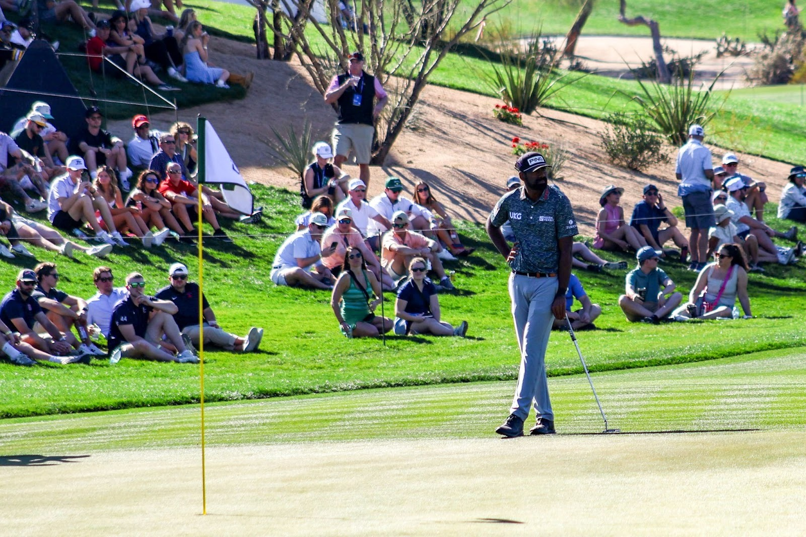
Sahith Theegala waits near the 6th green during Friday’s round at the 2026 WM Phoenix Open. Annika Morris/Special to The Republic
Six years later, Theegala’s L.A. ties still run deep.
“I was just honored that they even chose me for the (L.A. Golf Club) team,” Theegala said, “and to play for my hometown is pretty epic.”
Another of the original six teams, the Boston Common Golf Ballfrogs, are represented by two New England natives, including Michael Thorbjornsen, raised in Wellesley, Massachusetts.
“Just being affiliated with an entity or a team now that is stationed in Boston or in Massachusetts is pretty cool,” Thorbjornsen said.
Thorbjornsen, just 24 years old and only recently added to the Ballfrogs’ roster as a designated alternate, proved pivotal in his team’s first victories in the young league.
Thorbjornsen arrived at TGL's home base, the SoFi Center in Palm Beach Gardens, Florida, sporting a Drake Maye jersey. Maye, the quarterback for the New England Patriots, was in the midst of building a case for MVP and leading his team to the playoffs at the time.
“There’s definitely a sense of pride in being a part of that team,” Thorbjornsen said. “A lot of people have a lot of pride in where they’re from and where they grew up, so having another team to back and have some passion for is great for everyone.”

Will Neary is a graduate student at Northwestern’s Medill School of Journalism

